**Linux Hands-on Session Day-2**

**1) Install the java and set the environment variable.**

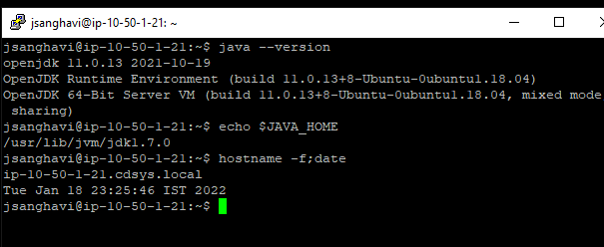

**2) Find the files which have size greater than 2 kb using the find command.**

find . size +2k

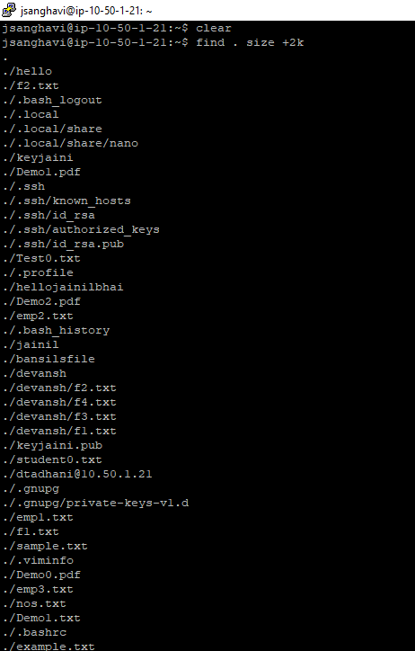

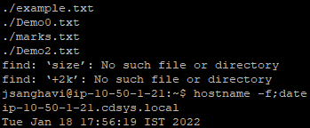

**3) List all the packages of the current system, grab the full version from the output. Sort it and store it in a file.**

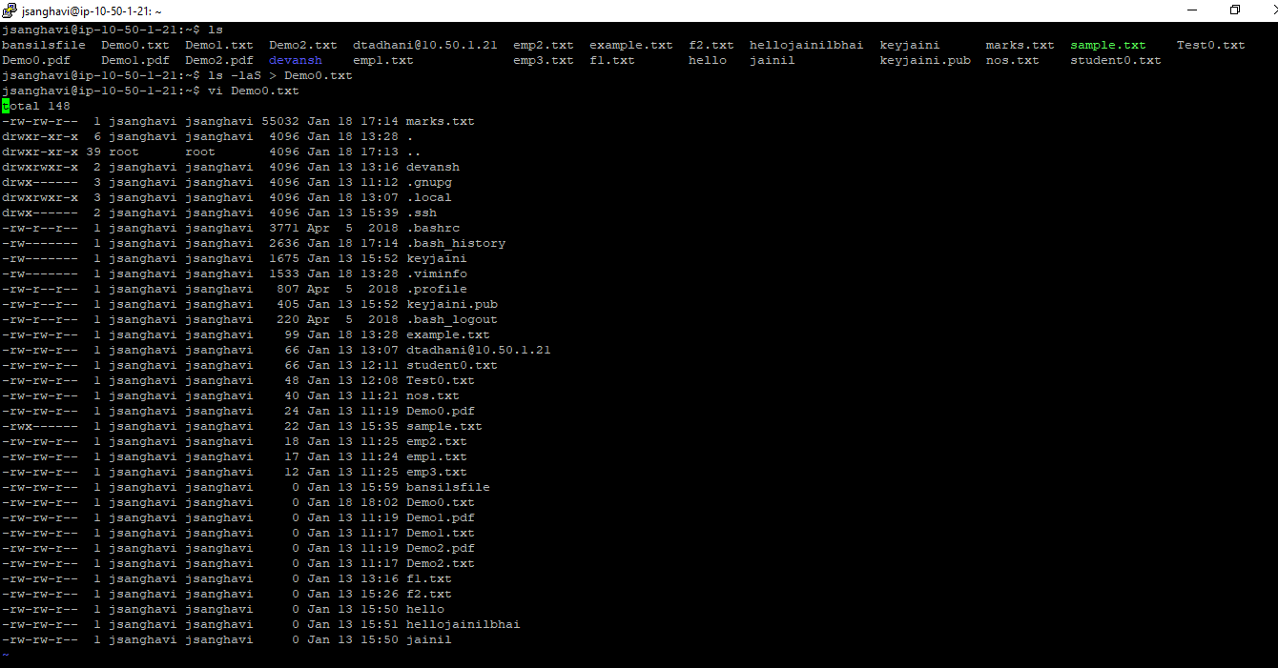

**4) How to find words in vi editor?**

We can find words by pressing / and write the word that you want to find.

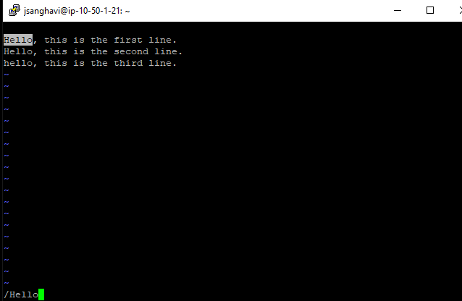

**5) How to go to the next occurrence using a shortcut in vi editor?**

In the command line, we just need to press "n" for the next occurrence of the word or "N" for the previous occurrence of the word.

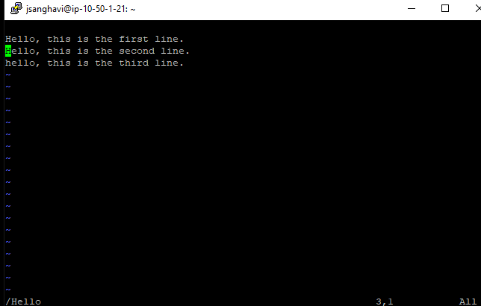

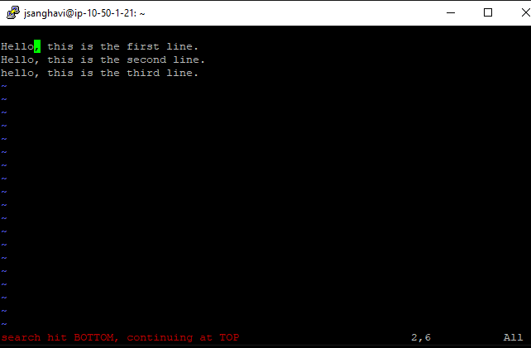

**6) How to go to the end of a file in vi editor?**

To end a file in vi editor, press the "Esc" key and then press "Shift + G" to move the cursor.

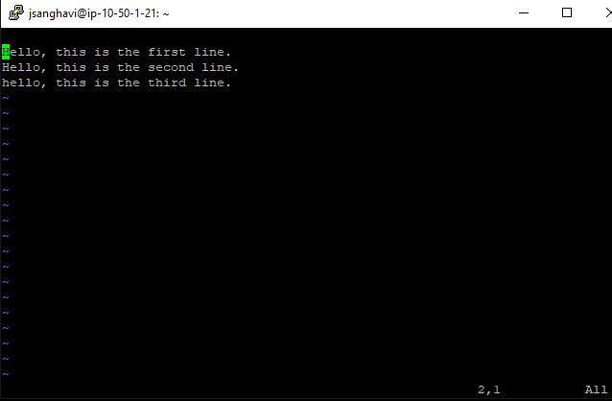

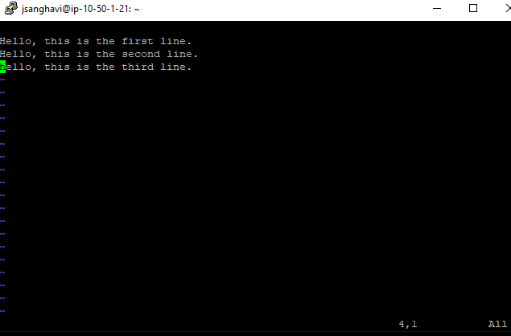

**7) What is the shortcut for copy/paste in vi editor?**

* Position the cursor where you want to begin cutting.
* Press v to select characters or uppercase V to select the whole line.
* Move the cursor to the end of what you want to cut.
* Press d to cut or y to copy.
* Move to where you would like to paste.
* Press P to paste before the cursor, or p to paste after.

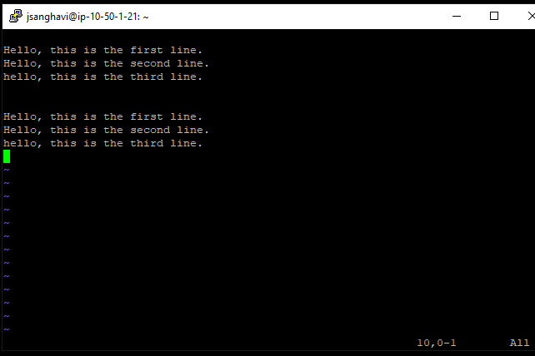

**8) Find and replace words in vi editor.**

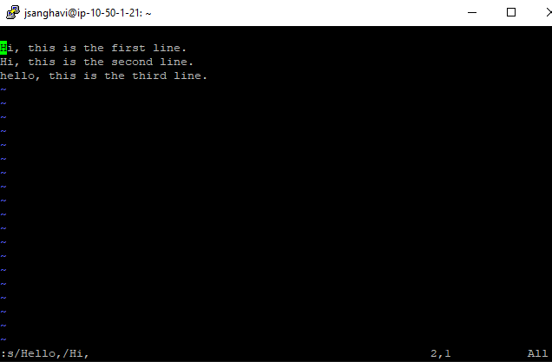

**9) How to search a string in reverse order in vi editor.**

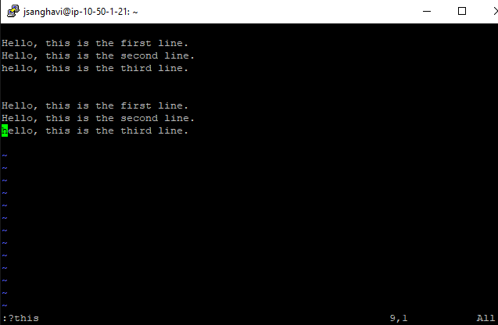

**10) Explain all the attributes of the TOP command.**

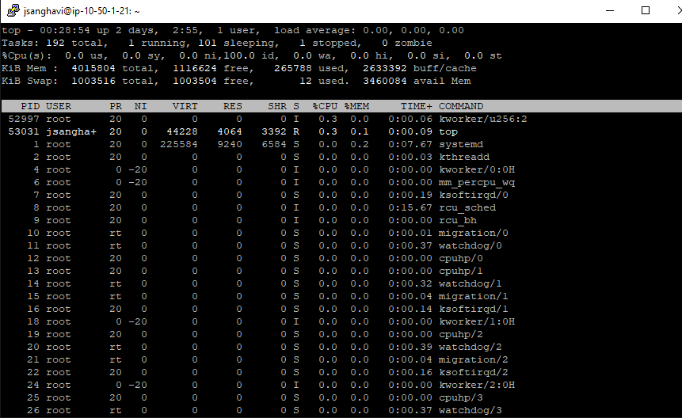

Top command is used to show the Linux processes. It provides a dynamic real-time view of the running system.

* PID: Shows task's unique process id.
* PR: Stands for priority of the task.
* SHR: Represents the amount of shared memory used by a task.
* VIRT: Total virtual memory used by the task.
* USER: User name of owner of task.
* %CPU: Represents the CPU usage.
* TIME+: CPU Time, the same as `TIME', but reflecting more granularity through hundredths of a second.
* SHR: Represents the Shared Memory size (kb) used by a task.
* NI: Represents a Nice Value of task. A Negative nice value implies higher priority, and positive Nice value means lower priority.
* %MEM: Shows the Memory usage of tasks.

**11) How to find the parent process ID of a process.**

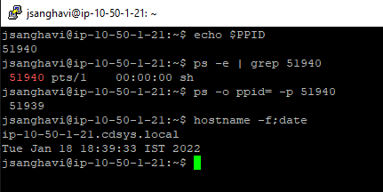

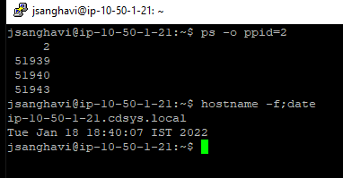

**12) Explain how you can create a folder using Terminal?**

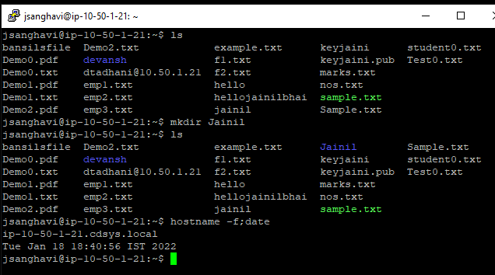

**13) Create a user and group of your name and add the user into a group. Set expiry of user to 3 days.**

**Creating a new user with expiry date:**

sudo useradd jsanghavi

sudo usermod -e 2022-01-21 jsanghavi

**Shows expiry date of user:**

Sudo chage -l jsanghavi

**Create a new group named jainil:**

sudo groupadd jainil

**Adding user in jainil group:**

Sudo useradd jsanghavi jainil

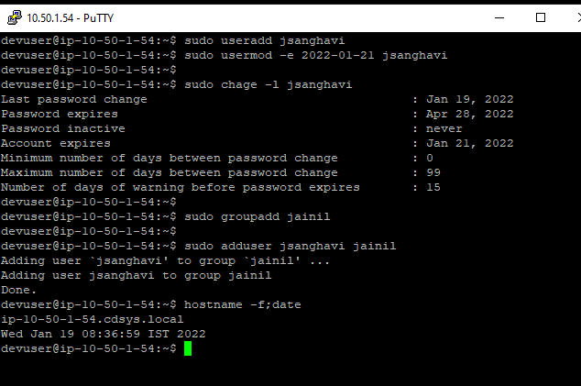

**14) Analyze which process is using how much memory.**

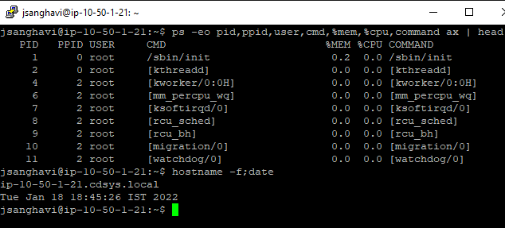

**15) Create a file with the name of your friends from the terminal only without using any text editors.**

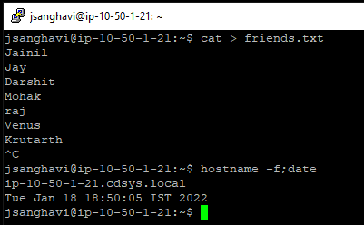

**16) Rename the file to friends_list.txt**

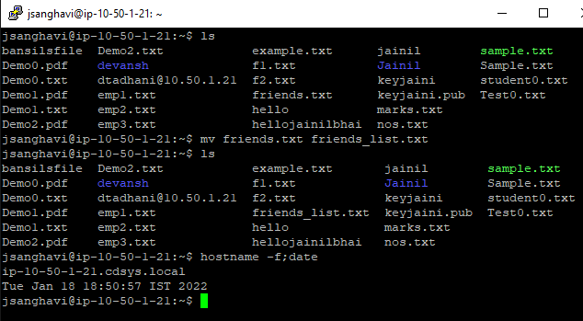

**17) Find the storage occupied by friends_list.txt in bytes.**

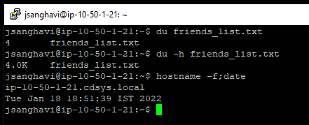

**18) List down other ways to identify the storage occupied by friends_list.txt in human readable format.**

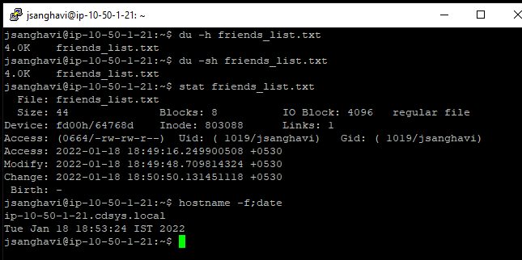

**19) Create another file with names of your family members in it.**

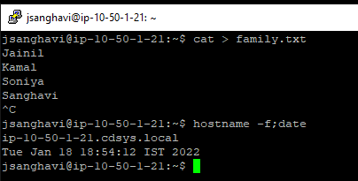

**20) Concatenate friends_list.txt and family.txt directly from the terminal and sort the combined file in alphabetical order. Keep filename to be combined.txt**

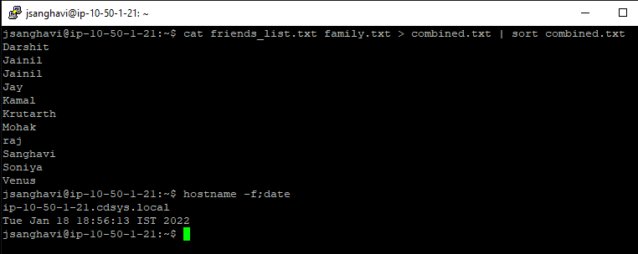

**21) Display the contents of combined.txt on the terminal screen and keep it interactive so that not all the list will be displayed and you need to scroll up and down to view the content.**

less combined.txt

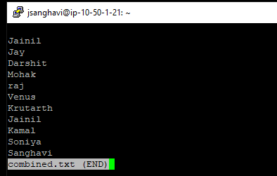

**22) Which directory contains the Linux kernel.**

The kernel file, in Ubuntu, is stored in your /boot folder.

**23) How to exit from vi editors.**

vi editor is exit using the following commands:

* :q for quit
* :q! for quieting without saving
* :wq for save and exit